

* **Overview:**

* Framework for building web applications in Java
* Based on Model-View-Controller design pattern.
* Leverages features of the core Spring Framework (IoC, DI).

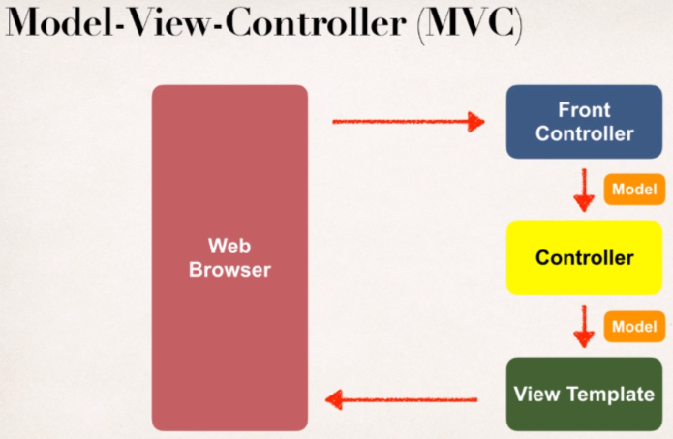

Basically, we have an incoming request coming from a browser and it will encounter the Spring MVC front controller and it will actually delegate the request of to a Controller code that contains the business logic and then it will create a model and send back to the Front Controller and then it will pass the model to our View Template and View Template is like a JSP page or HTML page which will render the data and give as a response to the browser.

* **Spring MVC Behind the Scenes:**

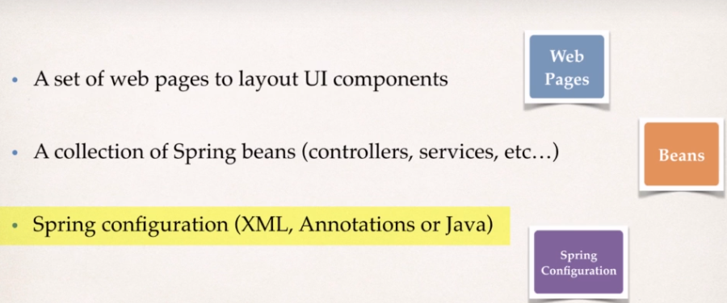**Components of a Spring MVC Application**

**Spring MVC Front Controller:**

* Front Controller known as ***DispatcherServlet*.**
* Part of the Spring Framework.
* Already developed by Spring Dev Team

This Front Controller will actually delegate the requests coming from browser to some other objects in our system.

* So as a developer we will create
* **M**odel Objects
* **V**iew Templates (like JSP page)
* **C**ontroller Classes (Actual business logic)

**Controller:**

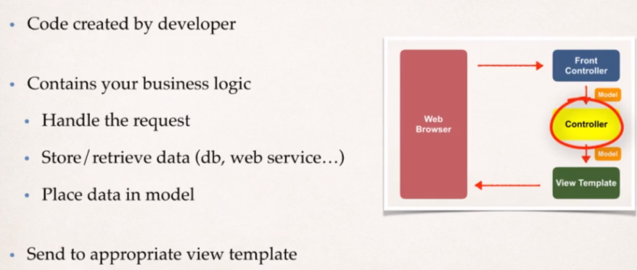

**View Template:**

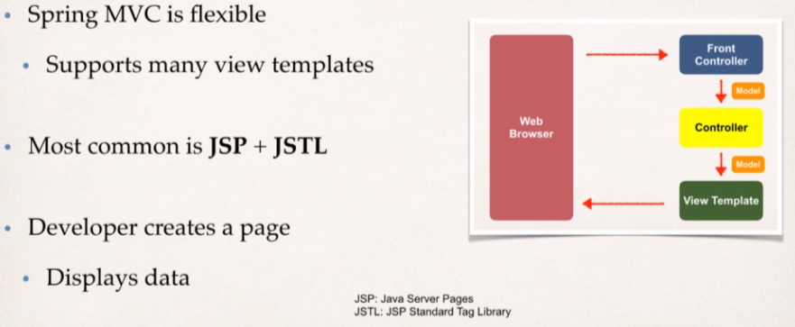Spring MVC is very flexible and there is many view template types. The model data comes to our JSP page and view template will read that data and display it. Other view Templates supported are Thymeleaf, Groovy, Velocity, Freemarker, etc.

**Development Environment Checkpoint:**

We should have installed:

* Apache Tomcat
* Eclipse
* Connected Eclipse to Tomcat

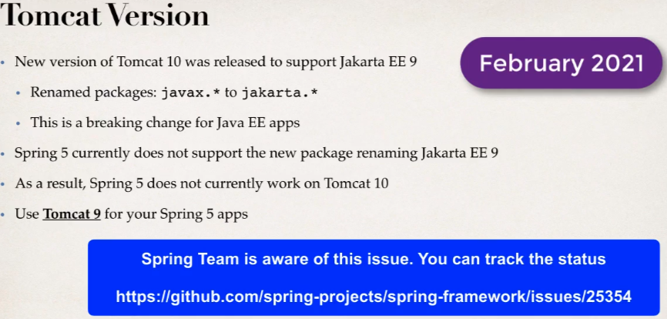

**Spring MVC Configuration:**

**Part 1: Add Configurations to file: WEB-INF/web.xml**

* Configure Spring MVC Dispatcher Servlet.

Here we will add an entry for Spring Dispatcher Servlet or the Front Controller within <servlet-name> tag. And we don’t need to do anything for Spring Dispatcher servlet as we will get it from spring jar files.

And then we will set up the initial parameter in which we tell where our spring context config file is located.

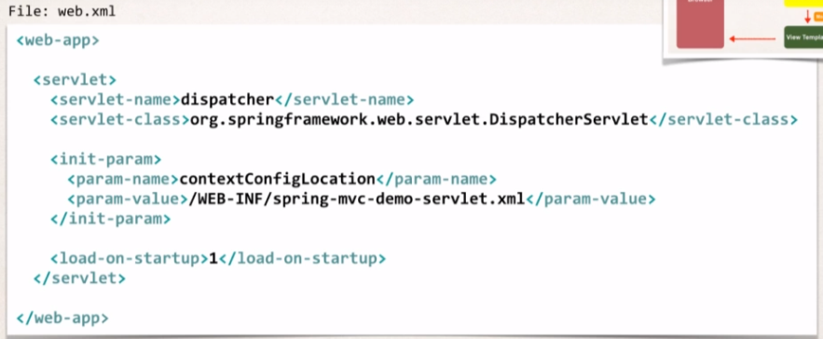

* Set up URL mappings to Spring MVC Dispatcher Servlet

Next thing is we want to tell the Spring that for any URL pattern coming in, we like it to pass to our Dispatcher Servlet. We can give what ever pattern we want till we are consistent with it.

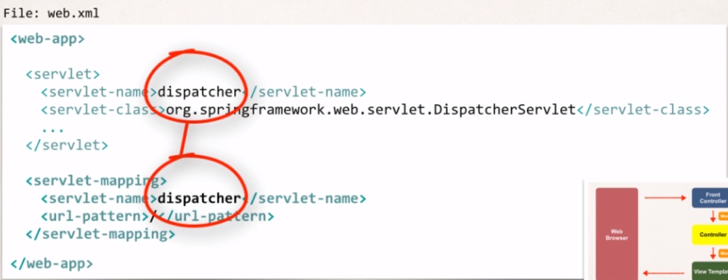

And the servlet-name while defining URL Pattern must matches with the servlet reference that we have set up above in step 1.

**Part 2: Add configurations to File: WEB_INF/spring-mvc-demo-servlet.xml**

* Add support for Spring component scanning.

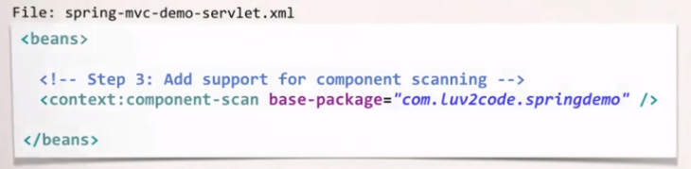

* Also add Support for conversion, formatting and validation.

When we are using Spring MVC then it can perform formatting of form data and can also perform form validation and in order to get the support we need to add this into our configuration xml file.

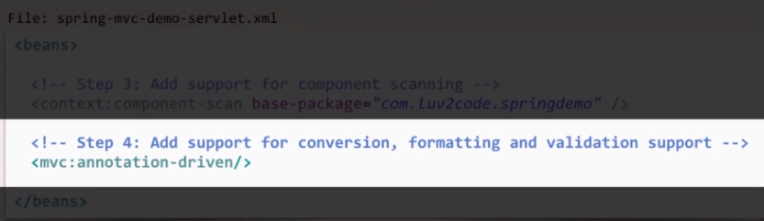

* Finally Configure the Spring MVC View Resolver.

In the final step, we will tell the spring where to look for files to actually render the view for our application.

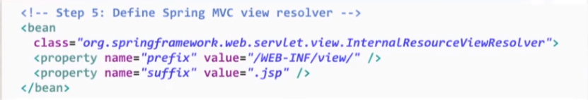

**When our app provides a “view” name, Spring MVC will**

* Prepend the prefix
* 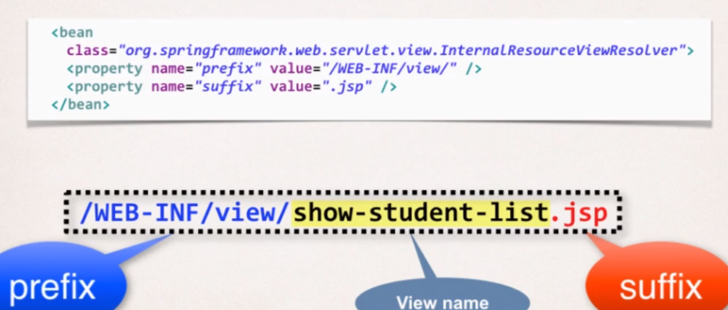Append the suffix to that view name automatically.

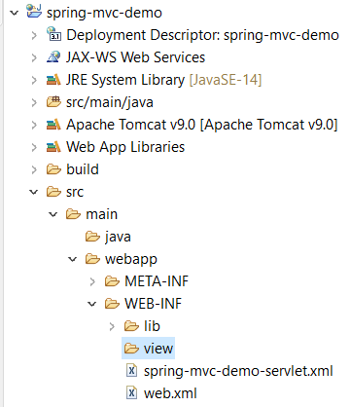 And we need to create this folder i.e., ***/WEB_INF/view/*** inside our project in Eclipse.

* During the Development on Eclipse, add the Spring framework jar file as well as JSTL jar files and it will automatically add those jars into our classpath of this project.

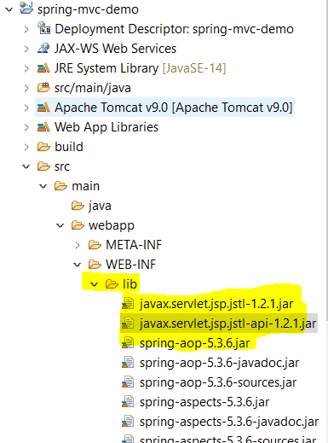

* Now we are going to add two starter files inside the WEB-INF directory in our project.

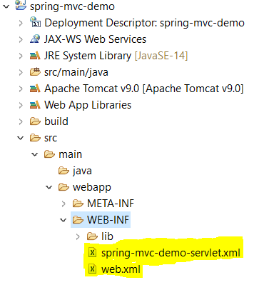Here spring-mvc-demo-servlet.xml is just our configuration file where we usually mention the Component scanning packages.



* **Creating a Spring Home Controller and View:**

**Development Process:**

* Create a Controller class

Annotate class with ***@Controller*.** And @Controller says that it’s a Spring MVC controller and ***@Controller inherits from @Component****,* and Spring does the scanning for @Component then it does pick @Controller as they extend from @Component.

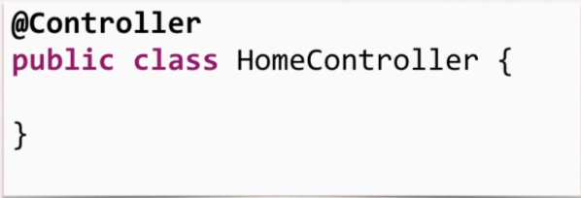

* Define a controller method.

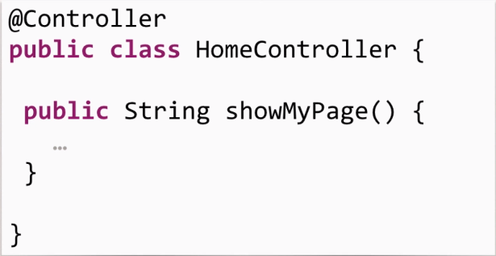

* 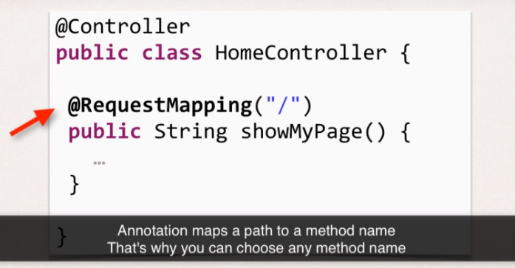Add the Request Mapping to the Controller method.
* Return View Name

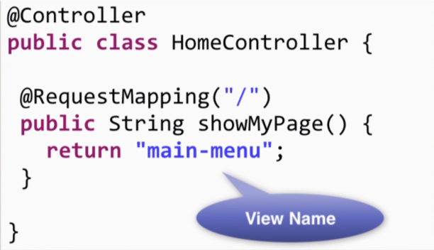

Remember There is some magic that’s going to happen in the background; Spring is going to take the information from it’s configuration file and it will actually find the view page. So based on the config it is going to look into the prefix directory and it will use the view name and then it will append the suffix ***(i.e.,******“.jsp” in our case)***

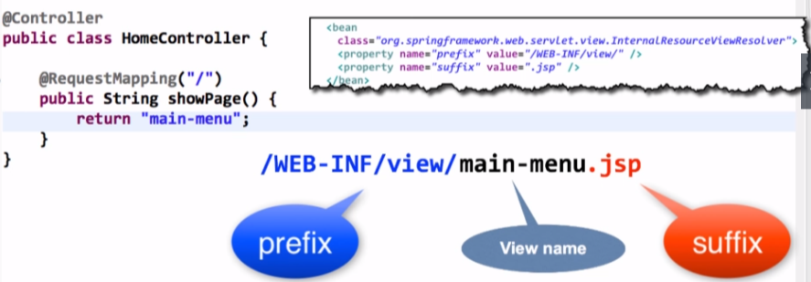

* Develop the View Page.

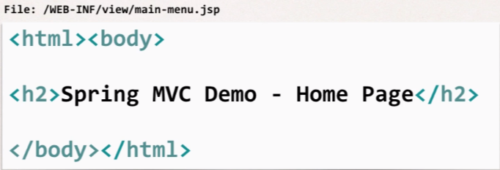

* **How to Read form Data with Spring MVC:**

Here We will have only one Controller with two Request Mappings, where user will first ask for the form and then submit the data and later controller will process it and then show it on the JSP page.

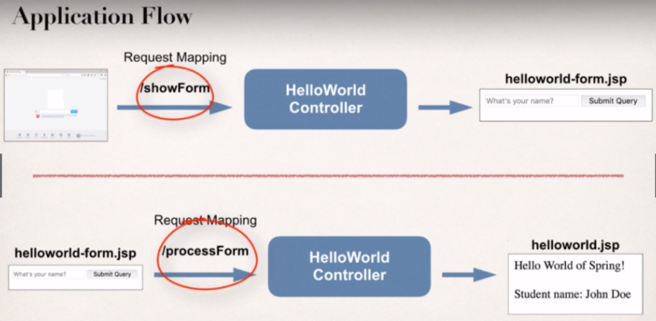

**Development Process:**

1. Create Controller Class.
2. **Show HTML form** 
   1. Create controller method to show HTML form.

//need a controller method to show the initial HTML form

@RequestMapping("/showForm")

**public** String showForm() {

**return** "helloworld-form";

}

//need a controller method to process the HTML form

@RequestMapping("/processForm")

p**ublic** String processForm() {

**return** "helloWorld";

**}**

* 1. Create View Page for HTML form.

File: helloworld-form.jsp

<form action=*"processForm"* method=*"GET"*>

<input type=*"text"* name=*"studentName"* placeholder=*"What's your name?"*/>

<input type=*"submit"*/>

</form>

1. **Process HTML Form** 
   1. Create Controller method to process HTML Form.
   2. Develop View Page for Confirmation

File: helloWorld.jsp:

<%@ page language=*"java"* contentType=*"text/html; charset=ISO-8859-1"*

pageEncoding=*"ISO-8859-1"*%>

<!DOCTYPE html>

<html>

<head>

<meta charset=*"ISO-8859-1"*>

<title>Insert title here</title>

</head>

<body>

<h3>Hello world of Spring!</h3>

Student Name: ${param.studentName}

</body>

</html>

* **Adding Data to Spring Model**

So, the Spring model is just a container to your application data.

In our Controller we can put any type of data

Like String, objects, info from the Database, etc. and our View page (JSP) can access data from the **model**.

**Passing Model to your Container:**

**Code Example-**

1. We want to create a new method to process form data
2. Read the form data: Student’s name
3. Convert the name to upper case
4. Add the uppercase version to the model.

In Spring MVC, when we create our controller method and we need to read our form data in controller then we pass any Http server request and it works like any Servlet Request and also, we can pass our model.

When we need to add something to the model then we call

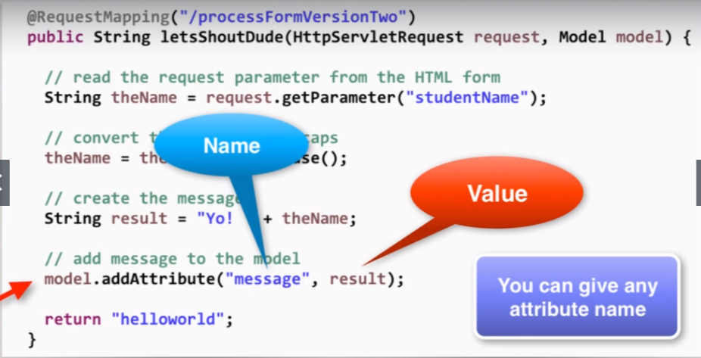**model.addAttribute()** and in the parameter we give model attribute name and then it’s value (that’s simply the name and value pair inside the addAttribute() method).

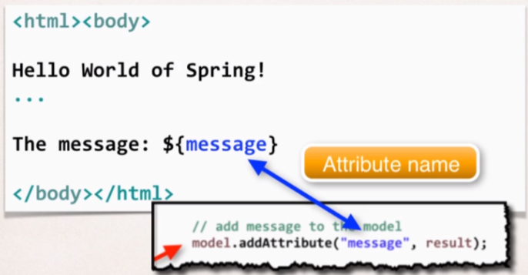And on the View Page (JSP) we can access the data from the model using the attribute name that has been set in the controller class.

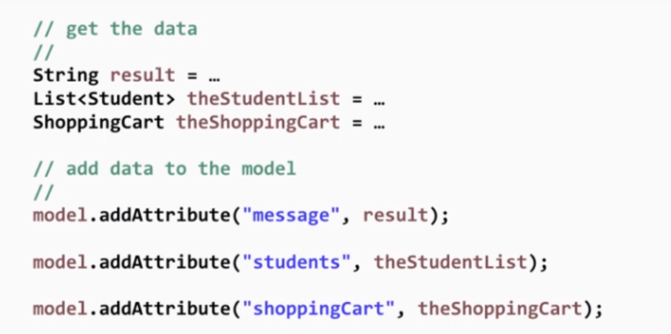And we can add any amount of data to the model, here is the example shown below:



* **Reading HTML Form Data with *@RequestParam* Annotation**

Earlier we were getting the form data using ***HttpServletRequest*** and then we’re using *getParameter(“studentName”)* but now we will read the form data i.e., “studentName” using ***@RequestParam.***

Spring has this special annotation which will read the form data from request Parameters and then it will take that data and it will bind with the variable like here we have ***theName*** in our example.

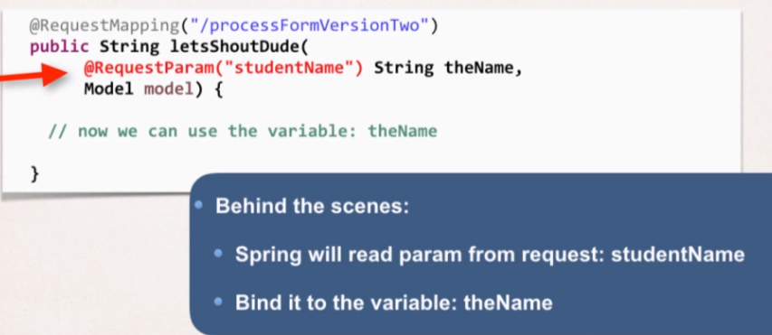 And then we are good to perform rest of the operations on the form data which is inside the ***theName*** variable.

* **Controller Level Request Mapping:**

Adding Request Mappings to controller:

* Serves as parent Mapping for Controller.
* 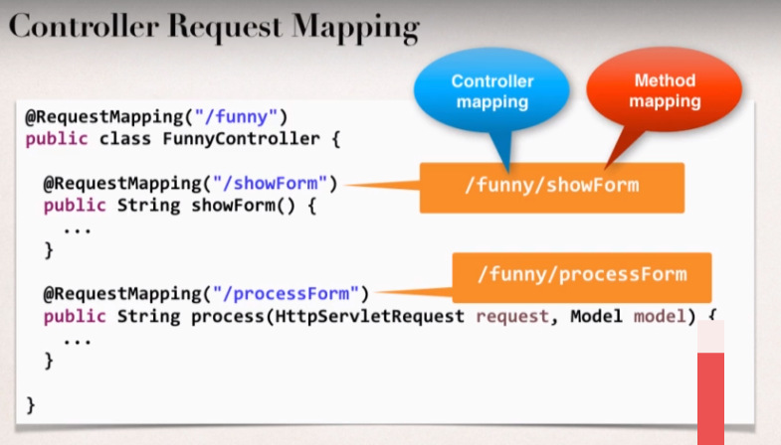All request Mappings on methods in the controller are relative.

Here we will see the conflict that we can get when we have two request mappings with similar name.

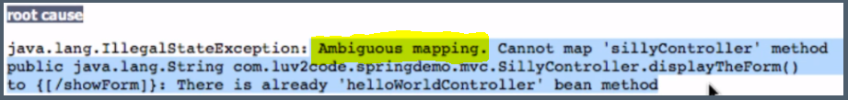This is the **error** we will get when we have the above-mentioned scenario;

**FAQ: How does "processForm" work for "/hello"?**

**Question: Can you please clarify how /hello is getting appended to the jsp file action for "processForm"?**

**Answer**

You can use "**processForm**" because it is a relative path to the controller "/hello" request mapping. Here is how it works.

1. When you wish to view the form, the HTML link points to "hello/showForm". This calls the controller and it displays the form.

2. At this point the browser URL/path is: *http://localhost:8080/spring-mvc-demo/hello*

3. The HTML form uses "processForm" for the form action. Notice that it does not have a forward slash, as a result, this will be relative to the current browser URL. Since the current browser URL is

*http://localhost:8080/spring-mvc-demo/hello*

Then the actual form URL submission will send it to

*http://localhost:8080/spring-mvc-demo/hello/processForm*

The part in bold with map to the controller with top-level request mapping "/hello" and then map to request mapping in that class "/processForm"

The key here is relative path of showing the form and then submitting to relative path.

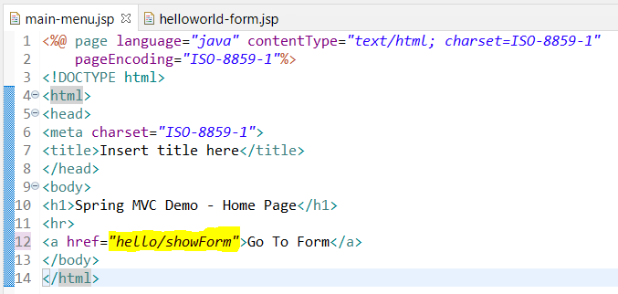

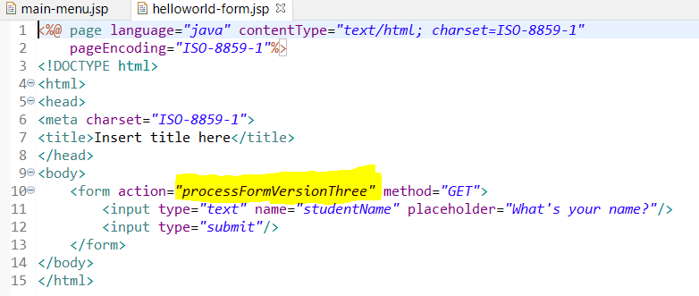

* **Spring MVC Form Tags Overview**

Spring MVC has support for Form tags and these form tags are configurable and we can reuse them for a web page.

**Data Binding**

Spring MVC Form Tags support data binding.

It allows us to automatically set data and retrieve data from a Java objects and beans.

* 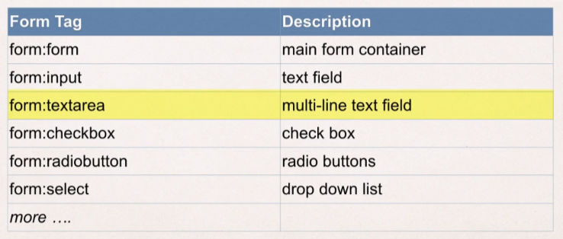Spring MVC Form tags:

We’ll make use of normal JSP page and then we can simply drop the Spring MVC Form tags.

**How to reference Spring MVC Form Tags?**

Specify the Spring namespace at the beginning of the JSP file.

<%@ taglib prefix=*"form"* uri=*"http://www.springframework.org/tags/form"* %>

Once that’s get setup, we can make use of Spring MVC form tag in our JSP page.

* **Spring MVC Form Tag for TextField:**

In our Spring Controller:

* We must add ***model Attribute.***
* This is a bean that will actually hold form data and this will give us the support for data binding.

So, when we show the form, we need to add the model attribute and here we have Model parameter and model will pass the data between controllers and views.

In this example, we are giving the “*model name”* as *“student”* and then as value we’re giving the object of student type (empty object), that will get pass to the form so that form make up with Data Binding.

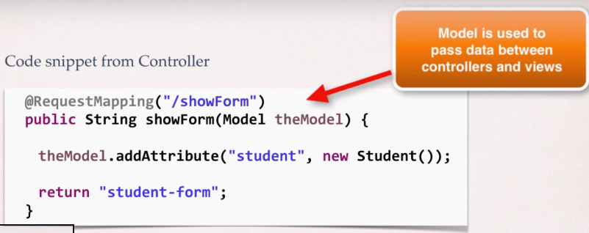And our Form should use the name as given in model name i.e., *student* to reference the student Object.

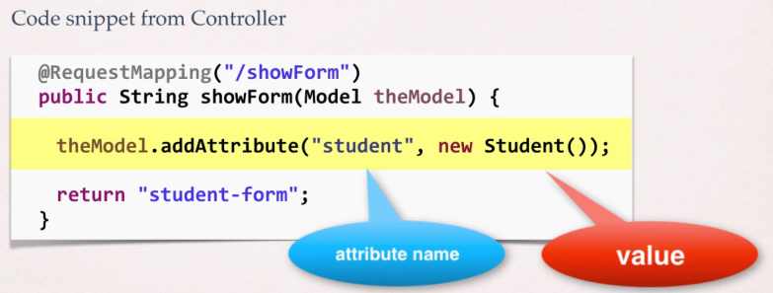

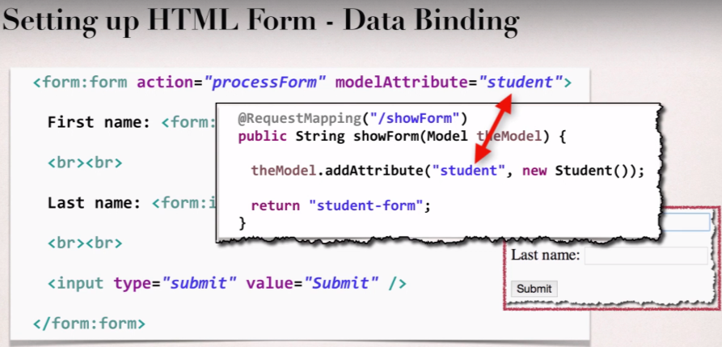

First Name: <form:input path=*"firstName"*/>

<br><br>

Last Name: <form:input path=*"lastName"*/>

The Highlighted part is actually binding this from field with the property of the bean. When is form is first loaded what Spring MVC will do behind the scene is it will actually populate the form Fields using getter methods of the Object property and if it returns null then the from will remain empty.

And when form get submitted Spring will call setter methods and it will use whatever data entered by the user into the form fields.

**Handling Form Submission in the Controller:**

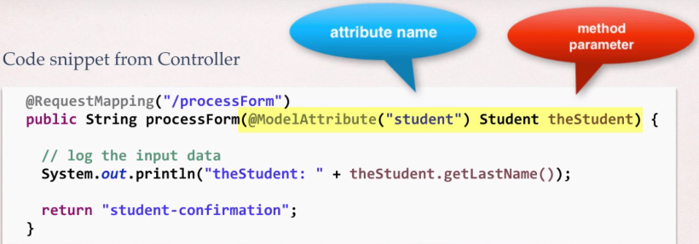 We will make use of new Spring annotation called *@ModelAttribute*.

Now that annotation will actually get the object using the Attribute name and pass it to the parameter ***Student theStudent*** and then we can use it in our controller method.

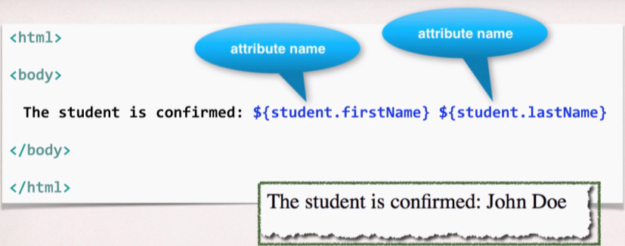So, we don’t need to do manually ***request.getParameter*** for each Form fields and Spring will handle all that for us.

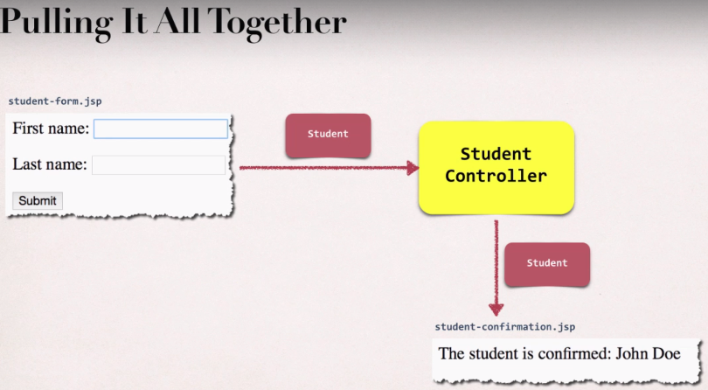

* **Spring MVC Form Tag – Drop Down List**

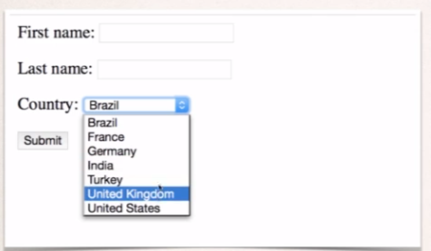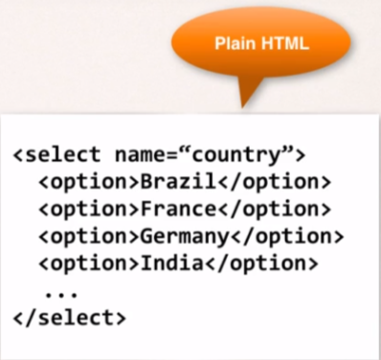

In the Spring MVC, Drop down list is represented by <form:select>

In <form:select>, we basically specify the path to the property of the Object and then we give the options in which value is the actual value that will get set using setter method of the property mentioned in the path attribute whereas label will be displayed on the view only.

*Example:*

Country:

<form:select path=*"country"*>

<form:option value=*"Brazil"* label=*"Brazil"*/>

<form:option value=*"France"* label=*"France"*/>

<form:option value=*"Germany"* label=*"Germany"*/>

<form:option value=*"India"* label=*"India"*/>

</form:select>

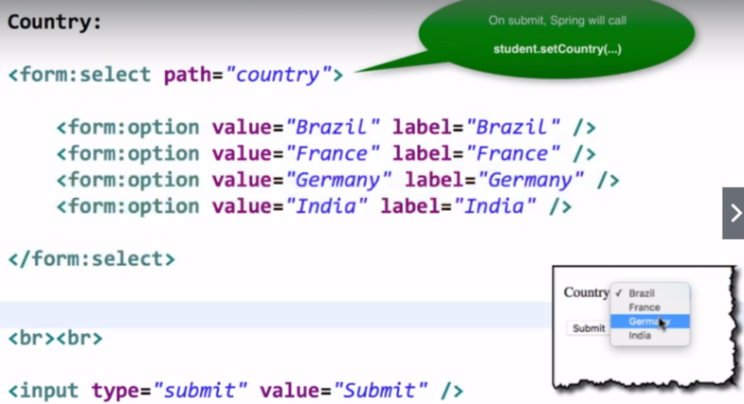

**Read the List of Countries from a Java class**

1. Define countryOptions inside the class.

**public** **class** Student {

String firstName;

String lastName;

String country;

String favoriteLanguage;

**private** LinkedHashMap<String, String> countryOptions;

**public** Student() {

//populate country options: used ISO country code

countryOptions = **new** LinkedHashMap<String, String>();

countryOptions.put("BR", "Brazil");

//"BR" is key/code and "Brazil" is value/label

countryOptions.put("FR", "France");

countryOptions.put("DE", "Germany");

countryOptions.put("IN", "India");

countryOptions.put("US", "USA");

}

.

. //getter and setters

.

.

**public** LinkedHashMap<String, String> getCountryOptions() {

**return** countryOptions;

}

}

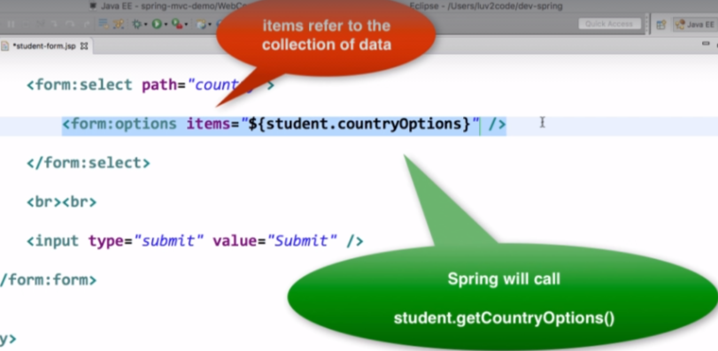Here we will need only the getter method for countryOptions, as when form is loaded, Spring will call ***student.getCountryOptions()*** method, to load the drop down items into the list.

So, this way we’re reading all the data form the Java class and we are not hardcoding it in the JSP page, and that java class can read the data from the property file or from Database or external services.

FAQ: Use properties file to load country options:

**Question:**

How to use properties file to load country options

**Answer:**

This solution will show you how to place the country options in a properties file. The values will no longer be hard coded in the Java code.

1. **Create a properties file to hold the countries. It will be a name value pair.  Country code is name. Country name is the value.**

New text file:  WEB-INF/countries.properties

1. BR=Brazil
2. FR=France
3. CO=Colombia
4. IN=India

Note the location of the properties file is very important. It must be stored in

*WEB-INF/countries.properties*

**2. Update header section for Spring config file**

We are going to use a new set of Spring tags for <util>. As a result, you need to update the header information in the Spring config file.

File: spring-mvc-dmo-servlet.xml

Remove the previous header and add this.

1. <?xml version="1.0" encoding="UTF-8"?>
2. <beans xmlns="http://www.springframework.org/schema/beans"
3. xmlns:context="http://www.springframework.org/schema/context"
4. xmlns:mvc="http://www.springframework.org/schema/mvc"
5. xmlns:util="http://www.springframework.org/schema/util"
6. xmlns:xsi="http://www.w3.org/2001/XMLSchema-instance"
7. xsi:schemaLocation="
8. http://www.springframework.org/schema/beans
9. http://www.springframework.org/schema/beans/spring-beans.xsd
10. http://www.springframework.org/schema/context
11. http://www.springframework.org/schema/context/spring-context.xsd
12. http://www.springframework.org/schema/mvc
13. http://www.springframework.org/schema/mvc/spring-mvc.xsd
14. http://www.springframework.org/schema/util
15. http://www.springframework.org/schema/util/spring-util.xsd">

**3. Load the country options properties file in the Spring config file. Bean id: countryOptions**

File: spring-mvc-demo-servlet.xml.

Add the following lines:

<util:properties  id="countryOptions" location="classpath:../countries.properties" />

**4.1 In StudentController.java, add the following import statement:**

1. import java.util.Map;
   1. **Inject the properties values into your Spring Controller: StudentController.java**
2. @Value("#{countryOptions}")
3. private Map<String, String> countryOptions;
4. **Add the country options to the Spring MVC model. Attribute name: theCountryOptions**
5. @RequestMapping("/showForm")
6. public String showForm(Model theModel) {
8. // create a student object Student
9. Student theStudent = new Student();
11. // add student object to the model
12. theModel.addAttribute("student", theStudent);
14. // add the country options to the model
15. theModel.addAttribute("theCountryOptions", countryOptions);
17. return "student-form";
18. }
19. **Update the JSP page, student-form.jsp, to use the new model attribute for the drop-down list: theCountryOptions**
20. <form:select path="country">
21. <form:options items="${theCountryOptions}" />
22. </form:select>

**7. Remove all references to country option from your Student.java.**

* 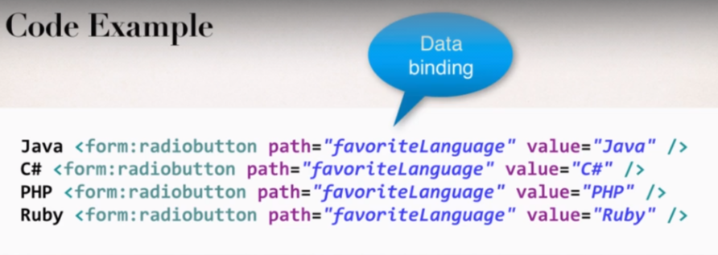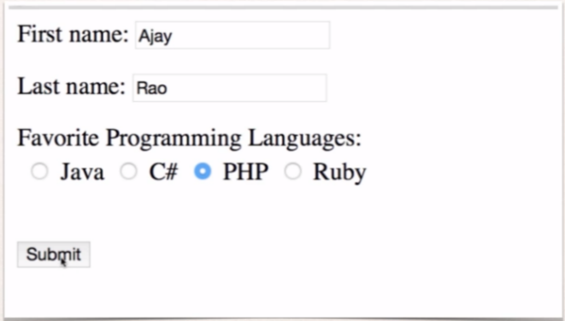**Radio Buttons:**

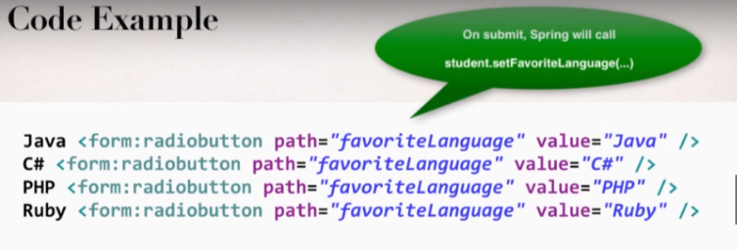Spring MVC Tag for A Radio Button is represented by the tag *<form:radiobutton>.*And we need to have the setter methods in our class for the above mentioned property

Inside the Student Java class add the property *favoriteLanguage*.

**public** **class** Student {

String firstName;

String lastName;

String country;

String favoriteLanguage;

.

. //getters and setters

.

.

**public** **void** setFavoriteLanguage(String favouriteLanguage) {

**this**.favoriteLanguage = favouriteLanguage;

}

**public** String getFavoriteLanguage() {

**return** favoriteLanguage;

}

}

And update the confirmation page.

FAQ: How to populate radiobuttons with items from Java class?

**FAQ: How to populate radiobuttons with items from Java class like we did with selectlist?**

You can follow a similar approach that we used for the drop-down list.

Here are the steps

1. Set up the data in your Student class

Add a new field

1. private LinkedHashMap<String, String> favoriteLanguageOptions;

In your constructor, populate the data

1. // populate favorite language options
2. favoriteLanguageOptions = new LinkedHashMap<>();
3. // parameter order: value, display label
4. //
5. favoriteLanguageOptions.put("Java", "Java");
6. favoriteLanguageOptions.put("C#", "C#");
7. favoriteLanguageOptions.put("PHP", "PHP");
8. favoriteLanguageOptions.put("Ruby", "Ruby");

Add getter method

1. public LinkedHashMap<String, String> getFavoriteLanguageOptions() {
2. return favoriteLanguageOptions;
3. }

2. Reference the data in your form

Favorite Language:  
          
        <form:radiobuttons path="favoriteLanguage" items="${student.favoriteLanguageOptions}"  />

* **Spring MVC form tags for Checkboxes:**

A check box is represented by the tag *<form:checkbox>*

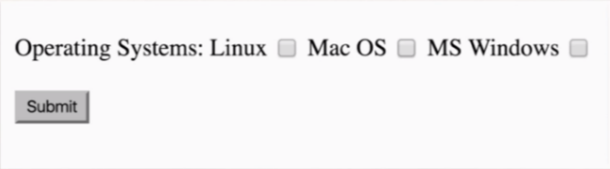

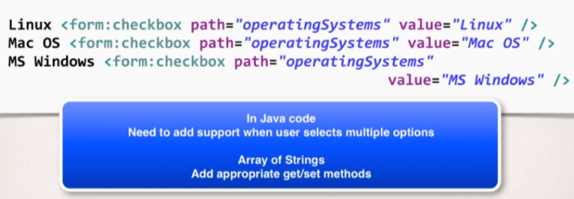

* Will update our ***student-form.jsp***:

Operating Systems:

Linux <form:checkbox path=*"operatingSystems"* value=*"Linux"*/>

Windows <form:checkbox path=*"operatingSystems"* value=*"Windows"*/>

MAC OS <form:checkbox path=*"operatingSystems"* value=*"MAC OS"*/>

<br><br>

* Now update the ***Student.java***

**public** **class** Student {

String firstName;

String lastName;

String country;

String favoriteLanguage;

ArrayList<String> operatingSystems;

**private** LinkedHashMap<String, String> countryOptions;

**.**

**.**

**.**

**. //getters and setters and constructors**

**.**

**.**

**public** ArrayList<String> getOperatingSystems() {

**return** operatingSystems;

}

**public** **void** setOperatingSystems(ArrayList<String> operatingSystems) {

**this**.operatingSystems = operatingSystems;

}

}

* Now we need to update the ***student-confirmation.jsp*** page

Add the ***JSTL core tags*** which will allow us to loop over the collections.

<%@ taglib uri=*"http://java.sun.com/jsp/jstl/core"* prefix=*"c"* %>

<br><br>

Operating Systems User used:

<ul>

<c:forEach var=*"temp"* items=*"*${student.operatingSystems}*"*>

<li>${temp}</li>

</c:forEach>

</ul>

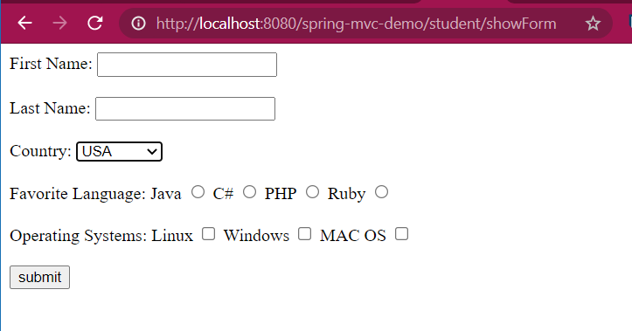 ***“items:”*** will call the getter methods for ***operatingSystems*** property of the model object and it will display all the selected operating systems in the bullet points structure.

We will get to look our student-from.jsp page on hitting the url:

[*http://localhost:8080/spring-mvc-demo/student/showForm*](http://localhost:8080/spring-mvc-demo/student/showForm)

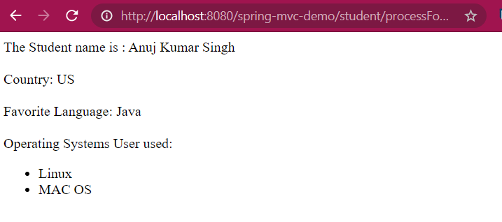And the *student-confirmation.jsp* will look like, (after processing the form)



* **Spring Form Validation**

We can use the Java’s standard bean validation API.

It defines a metadata model and API for entity validation.

And this bean validation API is available for service side applications and also client-side applications.

For more information: [*http://www.beanvalidation.org*](http://www.beanvalidation.org)

**Spring and Validation**

Spring version 4 or higher supports the Bean Validation API.

And it’s actually the preferred method for validation when building Spring apps.

We will simply add the Validation JARs to our project and use specified annotations and we are ready to go.

**Bean validation Features**

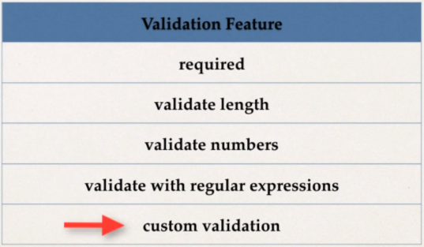

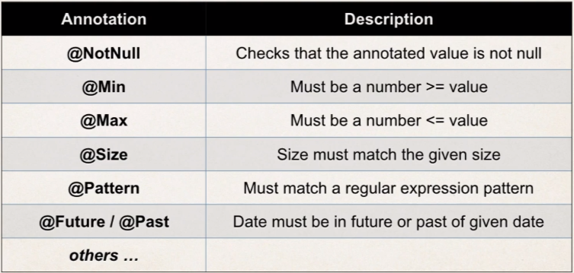

**Our Road Map**

* 1. Set up our development Environment
  2. Require field
  3. Validate number range: min, max
  4. Validate using regular expression (regexp)
  5. Custom validation
* **Setting up the development Environment:**

Java’s standard Bean validation API is only a specification, it’s vendor independent and portable however, we still need an implementation.

So, this is where Hibernate team comes to the rescue! And they have a separate project for validation. Hibernate Validator is fully complaint with Java’s standard bean validation API.

Website: [***http://www.hibernate.org/validator***](http://www.hibernate.org/validator)

About the versions!

* 1. Hibernate Validator 7 is based on Jakarta EE 9.
  2. Jakarta EE is the community version of Java EE (rebranded, relicensed)
  3. And Java EE is collection of enterprise API like servlets, JSP, JDBC, Enterprise java beans, Java Message Service, etc.
  4. Allows innovation of Jakarta EE with community driven approach.
  5. Jakarta EE does not replace Java EE.

**Jakarta EE**

1. At the moment main change with **Jakarta EE** is package renaming
2. ***javax.\**** packages are renamed to ***jakarta.\****

**What impact on Hibernate Validator?**

* Hibernate Validator 7 is based on **Jakarta EE 9**
* Spring 5 is still based on some components of **Java EE (*javax.*).***
* Spring may use Jakarta EE components in the future but no news yet.
* As a result, Spring 5 is not compatible with Hibernate validator 7
* **Hibernate Validator 6.2** is compatible with Spring 5.
* **Hibernate Validator 6.2** has the same features as Hibernate Validator 7.

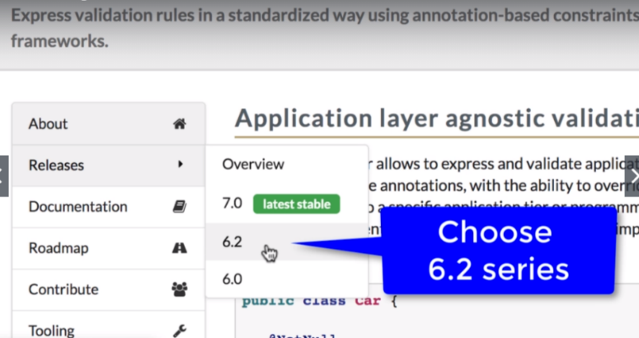**Download the Hibernate Validator 6.2 jar zip archive file** from [www.hibernate.org](http://www.hibernate.org) by going into the Validator section

* 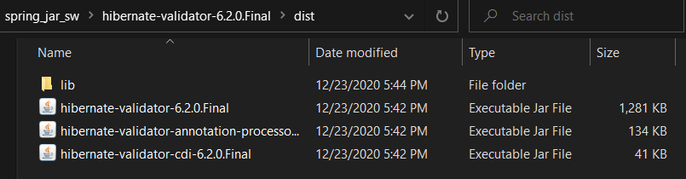On opening the zip archive file, go to **dist** directory and then copy all the three jar files present in that directory and then paste the jar files in the lib directory in the webapps folder of our project.
* 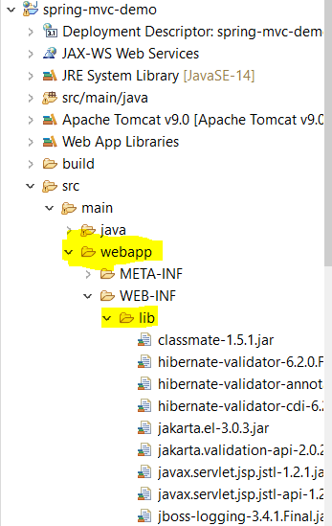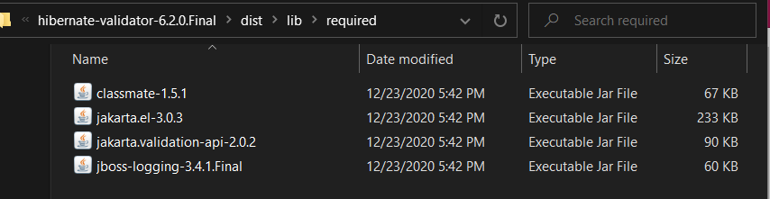And we will need some other required files as well which is present in *hibernate-validator-6.2.0.Final\dist\lib\required* and then copy them and paste into the webapps directory of our project.
* **Spring MVC Form Validation for Required Fields**

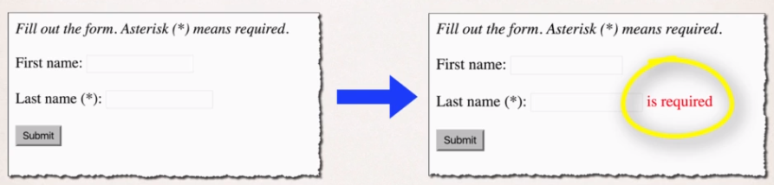In this example we will make the ***Last Name*** required for user to fill in.

**Development Process:**

1. Add Validation rule to Customer Class
2. Display error messages on HTML Form
3. Perform Validation in the Customer Class
4. Update Confirmation Page

* 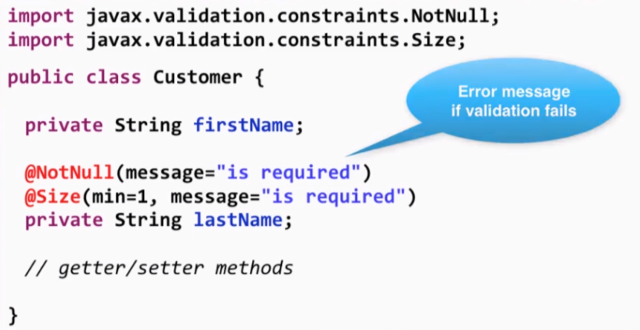**Add validation rule to Customer Class**
* **Display the Error Message on HTML Form**

Also add the reference for the Spring Form tag library.

<%@ taglib prefix=*"form"* uri=*"http://www.springframework.org/tags/form"* %>

With that add this **CSS styling** into the web page to show the error in red color

<head>

<meta charset=*"ISO-8859-1"*>

<title>Customer Registration Form</title>

<style>

*.error* {color:*red*}

</style>

</head>

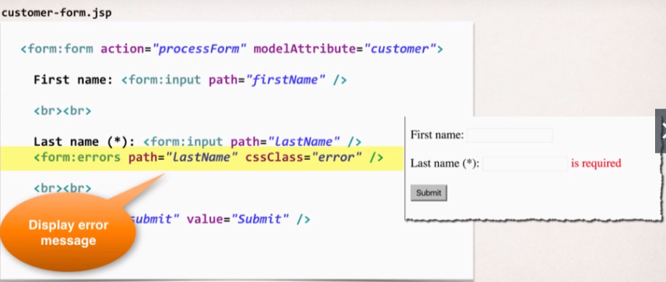

We will see the **error message** only if the validation gets fail.

* **Perform Validation in the Customer Class**

***@Valid*** will perform the validation rules using the ***Hiibernate Valdiator API*** on the object that we are getting from the form and then the result of the Validation test will be placed in ***theBindingRessult***.

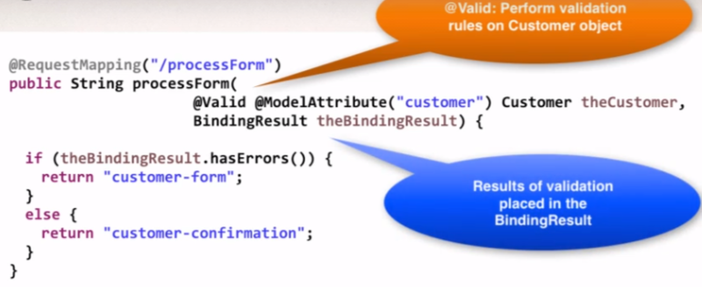Here we are checking if the ***bindingResult*** is having any error then will return to the same customer-form or else simply send them to the Confirmation page/success page of our application.

* **Update the Confirmation page**

<html>

<head>

<meta charset=*"ISO-8859-1"*>

<title>Customer Confirmation</title>

</head>

<body>

The Customer is confirmed: ${customer.firstName} ${customer.lastName}

<br><br>

</body>

</html>

Special Note about BindingResult Parameter Order

When performing Spring MVC validation, the location of the *BindingResult* parameter is very important. In the method signature, **the *BindingResult* parameter must appear immediately after the model attribute**.

If you place it in any other location, Spring MVC validation will not work as desired. In fact, your validation rules will be ignored.

1. @RequestMapping("/processForm")
2. public String processForm(
3. @Valid @ModelAttribute("customer") Customer theCustomer,
4. BindingResult theBindingResult) {
5. ...
6. }

Here is the relevant section from the Spring Reference Manual

---

***Defining @RequestMapping methods***

*@RequestMapping handler methods have a flexible signature and can choose from a range of supported controller method arguments and return values.  
...*

*The Errors or BindingResult parameters have to follow the model object that is being  
bound immediately ...*

**Let’s experiment and Break it up!**

In *CustomerController .java*; let’s add some logging message

@RequestMapping("/processForm")

**public** String processForm(@Valid @ModelAttribute("customer") Customer theCustomer,

BindingResult theBindingResult) {

System.***out***.println("Last Name: |"+ theCustomer.getLastName()+"|");

**if**(theBindingResult.hasErrors()) {

**return** "customer-form";

}

**else**

**return** "customer-confirmation";

}

Now let’s go to the customer-form.jsp on web page;

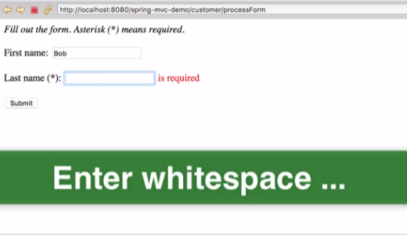We will try to enter Whitespace in last Name TextField and the submit it to check whether our validation will allow it pass through or not and that why we have added that logging message into the controller method.

Well, lastName field with **whitespace passes the validation** and let’s check the logging message into the console.

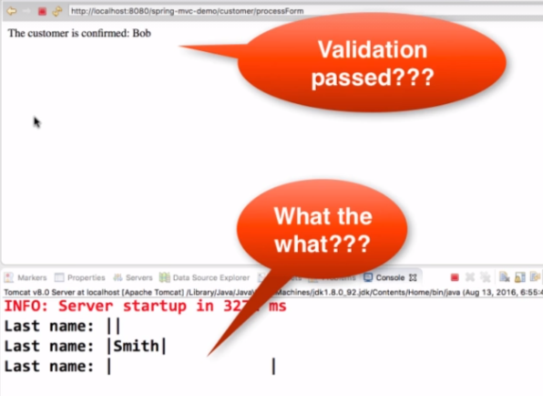So, how does it pass the validation as we have added @NotNull and @Size annotations?

The Solution is: ***@InitBinder***

what we need to do is trim the whitespace from the input fields.

1. @InitBinder annotation works as a pre-processor
2. Every Web request that will come to our Controller, this annotation code will execute first
3. Therefore, we’ll annotate a method with @InitBinder, then all requests coming in will get pre-processed.

So, we are going to use @InitBinder to trim the strings i.e., Remove the leading and tailing white space, and incase the string having just the whitespaces then we will trim it all the way to make it null object. This will actually resolve our validation issue.

**Development Process:**

1. Register the custom Editor in Controller and we will do that by using @InitBinder

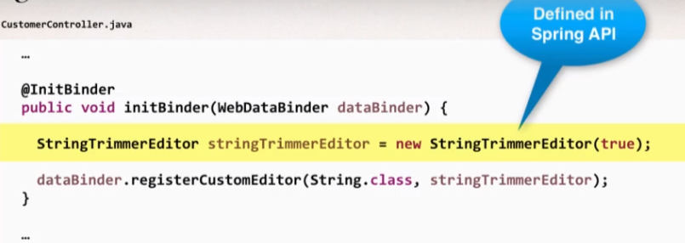

Here, we’re using the ***StringTrimmerEditor*** Class which is defined in Spring API, It’s purpose is to trim Strings.

*And in the constructor, we are keeping True Boolean value so that it can trim the String value to null.* Once the ***StringTrimmerEditor*** Object is created then we’re registering it to the ***dataBinder*** as a custom Editor. Actually, *we are saying that every String class apply the* ***StringTrimmerEditor****.*

1. 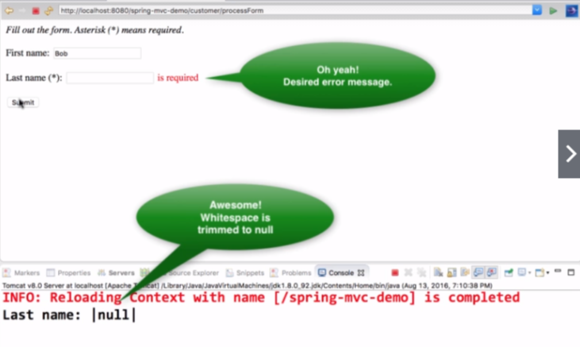Now, All the incoming requests will pass through the method annotated with @InitBinder and it will resolve our issue of whitespace with Last Name textField.

* **Validating a Number Range**

Will use @Min and @Max.

What are we going to do here?

* Add a new Input Field on our form for: **freePasses.**
* User can only enter a range: 0 to 10.

**Development Process**

* 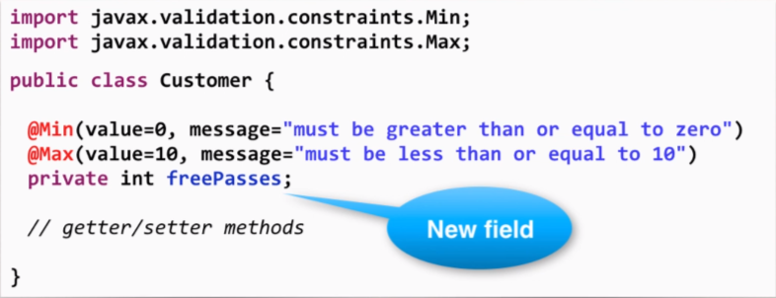Add Validation rule to Customer class

Message attribute is actually the error message that will generate if the validation failed.

* Display error messages on HTML form

File: customer-form.jsp <br><br>

Free Passes (*): <form:input path=*"freePasses"*/>

<form:errors path=*"freePasses"* cssClass=*"error"*/>

<br><br>

* Perform Validation in the Controller class

//nothing to do here, keep everything as it is

* Update Confirmation Page

File: customer-confirmation.jsp

<br><br>

Free Passes : ${customer.freePasses}

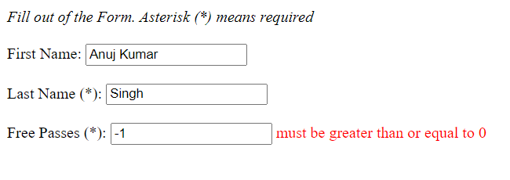

* **Applying Regular Expressions**

We’re going to validate the postal code field.

Validation Process

* Add a new input field on your form for: Postal Code
* User can only enter 5 chars/digit neither more than that nor less than; hence we will write the regular expression for that.
* 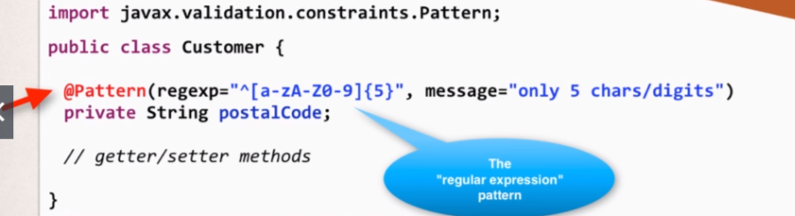Adding the Validation rule to Customer class:
* Display the Error message ono HTML Form

<br><br>

Postal Code: <form:input path=*"postalCode"*/>

<form:errors path=*"postalCode"* cssClass=*"error"*/>

<br><br>

* Update the Confirmation Page

<br><br>

Postal Code: ${customer.postalCode}

On running on server: So, Validation with Regular expression is working

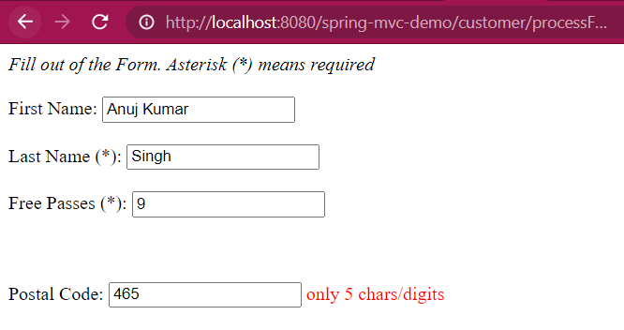

* **How to Integer Field Required?**

Added @NotNull annotation will make sure that the ***freePasses*** field is required.

**public** **class** Customer {

@NotNull(message="is required")

@Min(value = 0,message = "must be greater than or equal to 0")

@Max(value = 10,message = "must be less than or equal to 10")

**private** int freePasses;

**.**

**.**

**.**

**. //getters and setters**

**.**

}

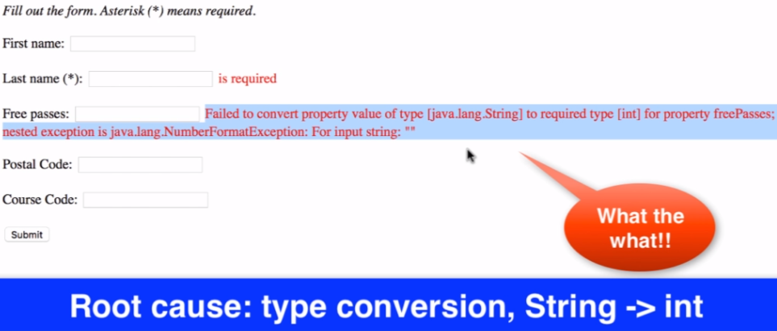Output we get is: root cause is TypeCoversion error i.e., not able to convert String type into the primitive type of int. So, we need to make the Type Integer rather than int.

**Fix**:

@NotNull(message="is required")

@Min(value = 0,message = "must be greater than or equal to 0")

@Max(value = 10,message = "must be less than or equal to 10")

**private** Integer freePasses;

We are using Integer wrapper class; it works because our @InitBinder annotated method StrimTrimEditor will actually trim the input to null if input is null or whitespace. And also update getters and setter in the class.

So, our aim of making field required has been met.

* 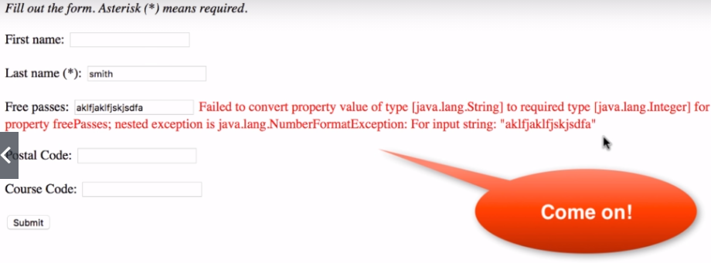***Submitting some String value for the Integer type field freePasses***, Let’s see the output:

**So, fix it, we will follow this Development Process:**

1. Create custom error message (“Invalid Number”)

We will create “*resource*” folder and within that we will put our *messages.properties* file

* *src/main/java/resources/messages.properties*

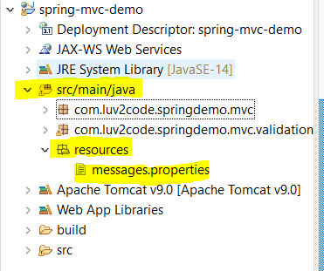

into the *messages*.*properties* file:

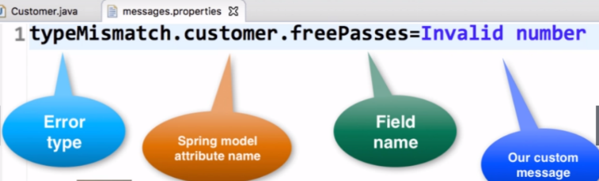

1. Load Custom messages resource in Spring config file.

Now we need to tell spring about our custom error message i.e., we will load this custom error message inside our spring config file.

Open the ***spring-mvc-demo-servlet.xml*** file, and add:

<!-- Load the custom Message resources -->

<bean id=*"messageSource"*

class=*"org.springframework.context.support.ResourceBundleMessageSource"*>

<property name=*"basenames"* value=*"resources/messages"*></property>

</bean>

1. 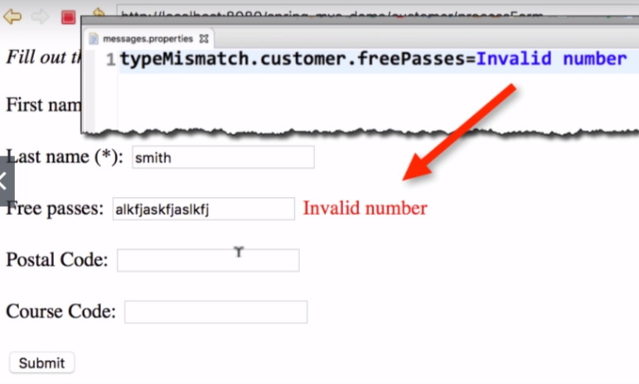Run on Server:

Now let’s see how we came up with text that we have written in *messages.properties* file.

So, we will add some logging message in our Controller method, in which we’ll inspect the ***bindingResult*** Object:

@RequestMapping("/processForm")

**public** String processForm(@Valid @ModelAttribute("customer") Customer theCustomer,

BindingResult theBindingResult) {

System.***out***.println("Last Name: |"+ theCustomer.getLastName()+"|");

System.***out***.println("Binding Result: "+theBindingResult);

System.***out***.println("\n\n\n\n");

**if**(theBindingResult.hasErrors()) {

**return** "customer-form";

}

**else**

**return** "customer-confirmation";

}

Now on giving some random string into the freePasses field, check for the logging message that we got:

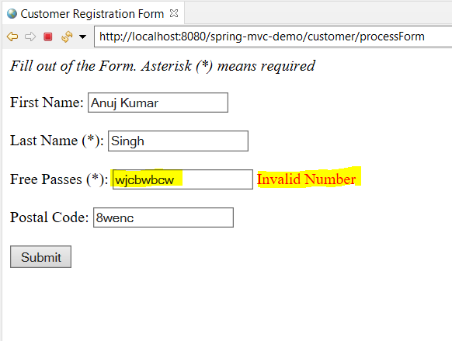

Logging Message:

Binding Result: org.springframework.validation.BeanPropertyBindingResult: 1 errors

Field error in object 'customer' on field 'freePasses': rejected value [wjcbwbcw]; codes [typeMismatch.customer.freePasses,typeMismatch.freePasses,typeMismatch.java.lang.Integer,typeMismatch]; arguments [org.springframework.context.support.DefaultMessageSourceResolvable: codes [customer.freePasses,freePasses]; arguments []; default message [freePasses]]; default message [Failed to convert property value of type 'java.lang.String' to required type 'java.lang.Integer' for property 'freePasses'; nested exception is java.lang.NumberFormatException: For input string: "wjcbwbcw"]

Look at the highlighted part; where error codes are given:

Rejected Value: [wjcbwbcw], It is the value that we have given in the input text field

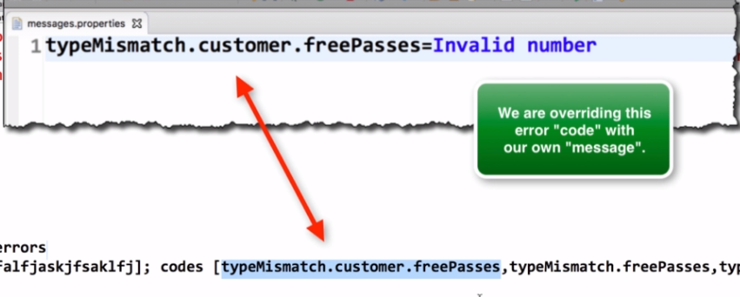Codes: [***typeMismatch.customer.freePasses***,typeMismatch.freePasses,typeMismatch.java.lang.Integer,typeMismatch]

*So, we are overriding their default error code and we are providing our own custom message.*

There is some other error codes mentioned in the array as well, basically error codes start with very specific error code from the left to very generic all the way to right in the array. Therefore, in this way we can use bindingResult to check the error codes and add our own custom message on unsuccessful validations.



* **Custom Validation with Spring MVC:**

Here we will add our custom annotation.

Ex: Custom Business Rule that we need to add here for the Course Code field

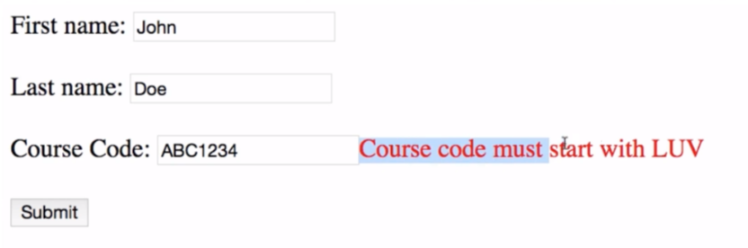So, here we want to start the course code form LUV and if user has written any other text then validation will give error by putting the message “Course must start with LUV”.

**Custom Validation**

* Spring MVC calls our Custom Validation
* Custom Validation returns Boolean value for pass/fail (true/false) based on the code user entered on the field/
* 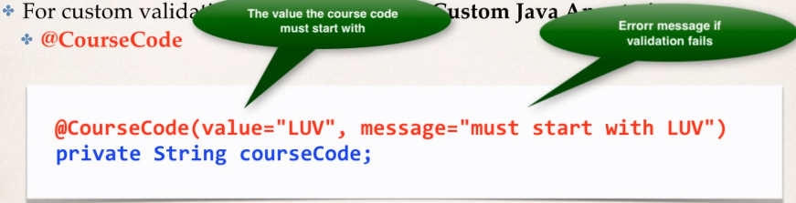We will create our own custom Java Annotation ***@CourseCode***

**Development Process**

1. Create custom Validation Rule

* Create ***@CourseCode*** annotation
* Create ***CourseCodeConstraintValidator Class***, this is where we put own custom Logic for Validation and determine true or false as if value passes our validation or not.

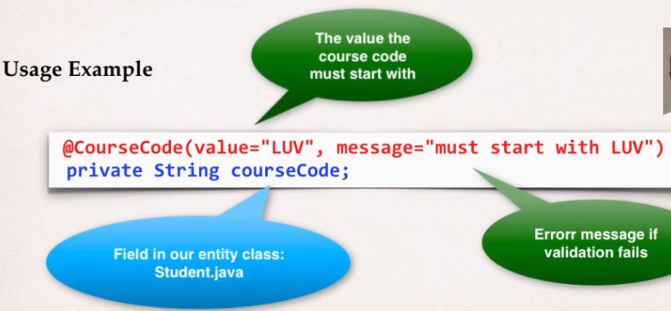

@Constraint(validatedBy = CourseCodeConstraintValidator.**class**)

@Retention(RetentionPolicy.***RUNTIME***)

@Target({ ElementType.***FIELD***, ElementType.***METHOD*** })

**public** **@interface** CourseCode {

* @Constraint with validatedBy property will actually contain the Helper class that has the business rule for validating the process.
* @Target basically says where can we apply this annotation like to a method or a field and here, we decided to put this annotation on method or on field.
* @Retention means how long we should retain it and we want to keep the annotation in the compiled java byte code so we can use it and intercept on it during runtime.

This annotation has two parameters i.e., “value” and “message”. So, we need to add some method declarations here inside the annotation.

//define the course code

**public** String value() **default** "LUV";

This means that the annotation has parameter called value and if user doesn’t provide then we will use the default value of “LUV”

//define default error message

**public** String message() **default** "must start with LUV";

//define default groups

**public** Class<?>[] groups() **default** {};

//define default payloads

**public** Class<? **extends** Payload>[] payload() **default** {};



* *Now* ***CourseCodeConstraintValidator*** *Helper class*

**public** **class** CourseCodeConstraintValidator **implements** ConstraintValidator<CourseCode, String>{

**private** String coursePrefix;

@Override

**public** **void** initialize(CourseCode theCourseCode) {

// **TODO** Auto-generated method stub

coursePrefix = theCourseCode.value();

}

@Override

**public** **boolean** isValid(String theCode, ConstraintValidatorContext theConstraintValidatorContext) {

// **TODO** Auto-generated method stub

**boolean** result = theCode.startsWith(coursePrefix);

**return** result;

}

}

***Code Explaination:***

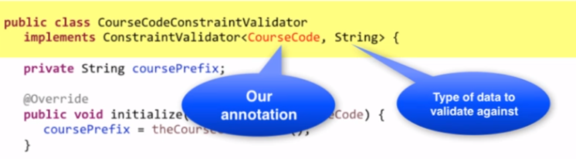

* **public** **void** initialize(CourseCode theCourseCode)

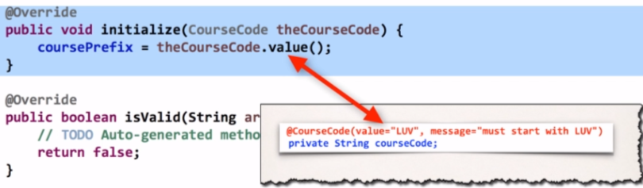

During initialization, it will get the actual value that passed in i.e., the prefix against which we want to validate in. This specially sets everything up, so our validator is up and running and now Spring MVC can actually use it for validation and then it takes us to another method isValid().

* **public** **boolean** isValid(String theCode, ConstraintValidatorContext theConstraintValidatorContext)

This method will be called by Spring MVC at runtime it will say here is the data submitted by the form and check if it’s valid? Spring MVC will pass the Form Data entered by the user in String theCode parameter and also pass the ConstrainstValidatorContext which is just a helper class for additional error messages.

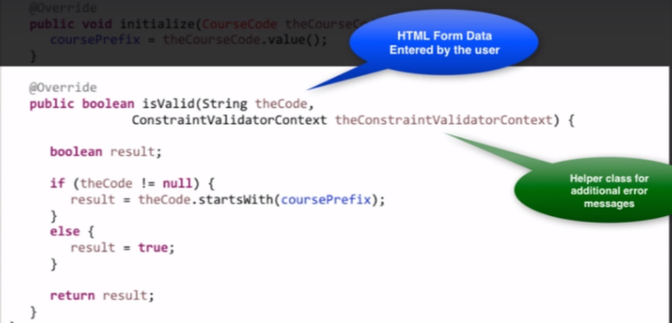

* **Business Rule:**

If the data (theCode) is not equal to null then we will check whether “*theCode*” start with the “coursePrefix” that is given in annotation’s **value** property and will return True/Flase based on that.

And incase **theCode** is empty i.e., ***null*** then we are simply returning ***True***.

1. Add validation rule to Customer class
2. Display error message on HTML from

File: customer-form.jsp

<br><br>

Course Code: <form:input path=*"courseCode"*/>

<form:errors path=*"courseCode"* cssClass=*"error"*/>

<br><br>

1. Update confirmation Page

File: customer-confirmation.jsp

<br><br>

Course Code : ${customer.courseCode}

**Now it will work as per our Business Rule:**

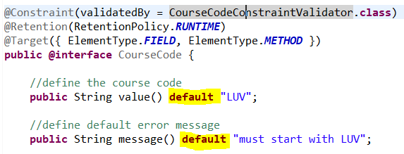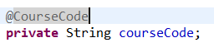

*Inside the Customer class*

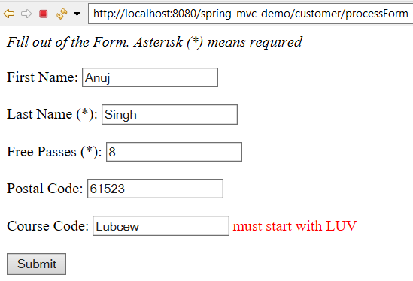

* Here *@CourseCode* will take default value and message that we have given while declaring the annotation.
* Below is the *customized version* of our *@CourseCode* annotation.

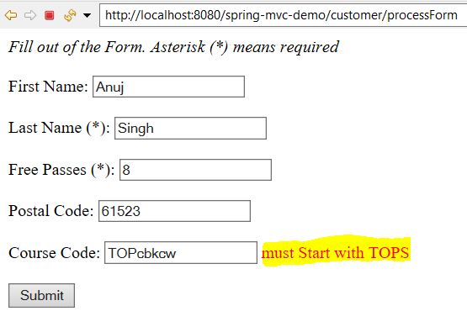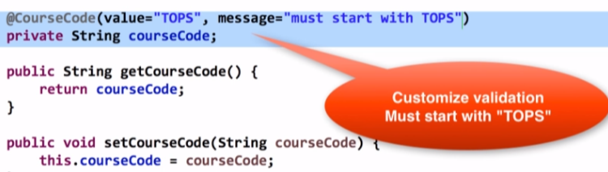

FAQ: Spring MVC Custom Validation - Possible to validate with multiple strings?

**Spring MVC Custom Validation - FAQ: Is it possible to integrate multiple validation string in one annotation?**

**Question:**

Is it possible to integrate multiple validation string in one annotation? For example, validate against both LUV and TOPS.

**Answer:**

Yes, you can do this. In your validation, you will make use of an array of strings.

Here's an overview of the steps.

1. Update CourseCode.java to use an array of strings

2. Update CourseCodeConstraintValidator.java to validate against array of strings

3. Update Customer.java to validate using array of strings

---

**Detailed Steps**

**1. Update CourseCode.java to use an array of strings**

Change the value entry to an array of Strings:

1. // define default course code
2. public String[] value() default {"LUV"};

Note the use of square brackets for the array of Strings. Also, the initialized value uses curley-braces for array data.

**2. Update CourseCodeConstraintValidator.java to validate against array of strings**

Change the field for coursePrefixes to an array

private String[] coursePrefixes;

Update the isValid(...) method to loop through the course prefixes. In the loop, check to see if the code matches any of the course prefixes.

1. @Override
2. public boolean isValid(String theCode,
3. ConstraintValidatorContext theConstraintValidatorContext) {
4. boolean result = false;
6. if (theCode != null) {
8. //
9. // loop thru course prefixes
10. //
11. // check to see if code matches any of the course prefixes
12. //
13. for (String tempPrefix : coursePrefixes) {
14. result = theCode.startsWith(tempPrefix);
16. // if we found a match then break out of the loop
17. if (result) {
18. break;
19. }
20. }
21. }
22. else {
23. result = true;
24. }
26. return result;
27. }
28. **Update Customer.java to validate using array of strings**
29. @CourseCode(value={"TOPS", "LUV"}, message="must start with TOPS or LUV")
30. private String courseCode;

Note the use of curley braces.

---

Complete Source Code:

<https://gist.github.com/darbyluv2code/0275ddb6e70e085a10fd464e36a42739>

---

That's it. This provides a solution to integrate multiple validation string in one annotation. In this example, the code validates against both LUV and TOPS.

Below GitHub Repository contains all the discussed exercises:

https://github.com/000GEV744/Spring-Git/tree/main/spring-mvc-demo